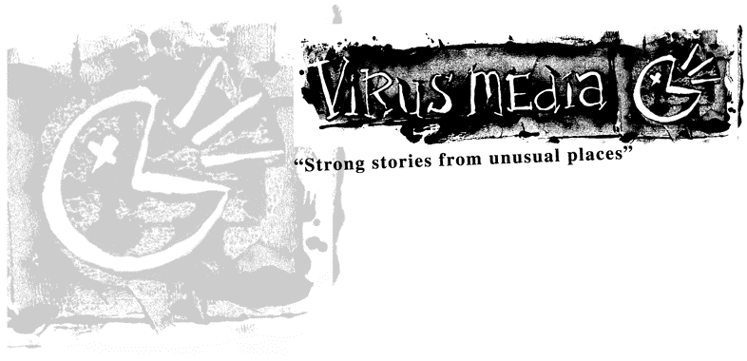

Habibi Jammin’ Press Kit

Habibi Jammin’ takes us behind the headlines and into the lives of four young people from the Arabic community in the troubled Western Sydney suburb of Bankstown.

Directed by Brian Rapsey
Produced by Enda Murray

Co-produced by Cinzia Guaraldi

Contact Details
Produced by Virus Media Pty Ltd
8 The Boulevarde, Lewisham, NSW 2049, Australia
Contact: Enda Murray enda@virusmedia.com.au

Tel +61 (0)2 95691313 Fax +61 (0)2 95691313 Mobile +61 (0)407 011176
www.virusmedia.com.au

Technical Details
Running Time 49 Minutes 15 Seconds
Digibeta 16:9 format PAL

Main Cast
NOMISe, Julie Kanaan,
Matuse and Susan Chamma

Key Crew
Camera Brian Rapsey
Oliver Lawrance
Editor Rochelle Oshlack
Consultant Producer Tom Zubrycki

Stills Photographer Sabine Albers
Additional Photography Brian Rapsey
Martin Brady
Sound Mixer Mike Gissing
Composer Matteo Zingales

Habibi Jammin’ Project conceived by Enda Murray

Writers Brian Rapsey
Enda Murray
Co-Producer Cinzia Guaraldi
Producer Enda Murray
Director Brian Rapsey

Shoot format: DVCam Finishing format: DigiBeta Aspect 16:9 Pal
Rating M Running Time 26 Minutes

Habibi Jammin’ One line synopsis
Habibi Jammin’ takes us behind the headlines and into the lives of four young people from the Arabic community in the troubled Western Sydney suburb of Bankstown.

Habibi Jammin’ 100 word synopsis
Habibi Jammin’ takes us behind the headlines and into the lives of four young people from the Arabic community in the troubled Western Sydney suburb of Bankstown. Nomise, Julie, Susan and Matuse are the most talented and articulate participants in the Jammin” in the Middle E drama project – which promises to produce a television drama based on stories from their lives. We follow them through the production stages of this unique drama process and explore the tricky topic of Arab/Australian representation.

Habibi Jammin’ One Page Synopsis
Habibi Jammin’ takes us behind the headlines and into the lives of four young people from the Arabic community in the troubled Western Sydney suburb of Bankstown. Nomise, Julie, Susan and Matuse are the most talented and articulate participants in the Jammin” in the Middle E drama project – which promises to produce a television drama based on stories from their lives. We not only follow them through the production stages of this unique drama process – we take the audience behind their front doors, into their workplaces, onto their streets and into their cars.

To be young and Arabic in Bankstown is to have lived through the last five years of negative racial stereotyping: Children Overboard, Tampa, September 11, “Lebanese gang rapes” and the Cronulla race riots. Habibi Jammin’is a first-hand account of being young and Arabic from a much neglected perspective; we hear from the irrepressible, hilarious and ambitious young Arabic men and women themselves.

The politics of representation rate highly in this project. The content revolves around how the young people feel they are perceived by the wider Australian public and what effect this has on the day-to-day activities in their lives – whether it be battling in front of a hostile audience at a rap battle or feeling protective toward their younger brothers and sisters in the face of adverse media hype.

The device of structuring the documentary around a film production provides lots of trigger points for personal experiences of what it means to be an Australian “who happens to pray five times a day”. The process of creating characters and nursing those characters through a dramatic script allows the doco to compare and contrast the dramatic characters with the reality of the young people’s lives.

Habibi Jammin’was filmed over a two year period. During that time we chart the unfolding events in our characters lives, losing jobs, finding work, starting college, successes, failures and even marriage!

The young people use wit and humour to invite the audience into their world as opposed to cajoling them with heavy-handed dogma. It’s a timely and charming expose of a much talked about but little understood sector of the Australian community.

Director’s Statement – Brian Rapsey

Habibi Jammin’ follows four characters (Julie, NOMISe, Matuse and Susan) through their involvement in a locally produced drama (Jammin’ in the Middle E), which was designed to reflect what it is like to be “young and Arabic” in Australia today. This documentary teases out their roles in this local production and links some of the characters’ criticisms (of Australian media, of the dominant culture, of the drama project itself) to broader issues of representation in a political climate of fear.

As a film-maker I was drawn to this project because of concerns over how a small group of people can become a vessel for projected fears and anxieties of mainstream society. Questions which arose for me during the making of this documentary also involved wondering what it meant for a group of young Arabic Australians to be asked to have a ‘voice’ by outsiders. How is this politics of self-representation an antidote to negative media representations? What is the tension between representing the ‘reality’ of their lives with the urge to create a positive image that will seduce the broader community. If, as Susan says, the “media is always pounding us down, pounding us down” then how might a community respond? Susan, NOMISe, Matuse and Julie each suggest different answers to this challenge. Consequently, this documentary is not an attempt to represent the realities of these people’s lives but rather examines how they are involved in their own representation via a drama project. How do they each respond to the finished drama? The documentary gestures towards the intricacies of self-representation itself and the roles that film and media can play in this.

Brian Rapsey Bio Director

Brian Rapsey is a Sydney-based documentary filmmaker who also works as an editor and photographer. He trained at the University of Western Australia and Victorian College of the Arts school of Film and TV and has since been actively involved in a broad range of film making projects around the country.

ENDA MURRAY Producer
Enda Murray is an award winning filmmaker with 20 years experience in program making having worked in Ireland, England, Europe, USA and Australia. Educated at Trinity College Dublin and St. Martin's School of Art in London, he has written, produced and directed several drama and documentary programs which examine the relationship between communities and popular culture. These include Sound System about Jamaican sound systems in Birmingham for Central TV in 1994, Gaelic Girls about Irish women emigrants playing Irish rules football in Sydney in 1997 and Reel Irish about three generations of Irish dancers in Britain in 1998. With his own production company, Virus Media, he originated and co-produced Road, an award-winning drama made collaboratively with young Aboriginal people in Sydney (Road was presented to the French government by the Australian Federal government as part of the Baudin cultural bequest in 2002). He also produced an on-line youth arts portal for young Palestinians and has written and produced three radio documentaries for ABC Radio Eye - Earthdreamers, about a travelling techno music circus, Wired Palestine about the use of the internet in the Middle East Conflict and Dereb – a profile of an Ethiopian musician living in Sydney.

In 2005 Enda created and produced Jammin’ in the Middle E - an Arab/Australian comedy short feature film about family, fast cars, gangsta rap and….rosewater! . Jammin’ in the Middle E was devised with young people from the Arabic speaking community in Bankstown and will screen on SBS TV in February 2006.

